Noise Pollution Monitoring

\*\*Components Needed\*\*:

1.Raspberry Pi or Arduino board

2.Sound sensor (e.g., a microphone sensor)

3.Wi-Fi module (e.g., ESP8266)

4.Breadboard and jumper wires

5.Tinkercad for simulation

6.Online dashboard (e.g., ThingSpeak or Adafruit IO)

\*\*Steps to create the project\*\*:

1.\*Hardware Setup\*:

-Connect the sound sensor to the Raspberry Pi or Arduino board using jumper wires.

-Connect the Wi-Fi module to the board for internet connectivity.

2.\*Coding\*:

-Write a program in Python (for Raspberry Pi) or Arduino IDE (for Arduino) to read data from the sound sensor.

-Use a library to convert the analog data from the sensor into decibel (dB) levels.

-Create a function to send this data to the cloud via the Wi-Fi module.

3.\*IoT Integration\*:

-Set up an account on a platform like ThingSpeak or Adafruit IO to collect and visualize data.

-Configure your code to send noise level data to your IoT platform account.

4.\*Data Visualization\*:

-Create a dashboard on the IoT platform to display real-time noise level data in a user-friendly format.

-You can also set up alerts if noise levels exceed a certain threshold.

5.\*Simulation in Tinkercad\*:

-Use Tinkercad to create a virtual prototype of your hardware setup.

-Simulate the interaction between the sound sensor, board, and Wi-Fi module.

6.\*Testing and Calibration\*:

-Test your system in a real-world environment to ensure accurate noise level readings.

-Calibrate the system to match real noise levels with dB readings.

7.\*Documentation and Presentation\*:

-Prepare a detailed project report documenting your design, code, and results.

-Create a presentation to explain your project to your peers and instructors.

8.\*Optional Enhancements\*:

-You can add GPS functionality to track the noise levels at different locations.

-Implement machine learning to analyze noise patterns and trends.

-Create a mobile app to access noise level data remotely.

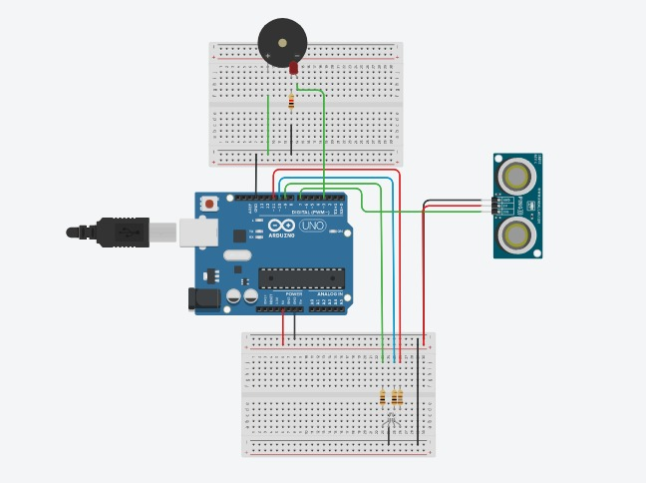

Fig: Noise Pollution Monitoring Sensors With Circuit

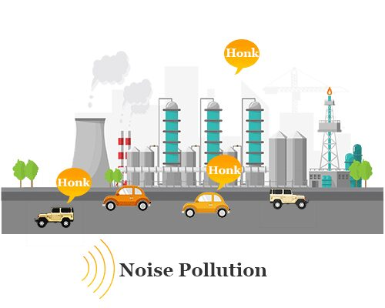

Fig: Noise Pollution Design